Installing Ruby

Installing Ruby
I use Ubuntu operating system, if you use Linux (Debian centric distro), open your terminal and type
sudo apt-get install ruby
You will be asked for your administrator password, once you give the password, Ruby will get installed. To check your installation, type
ruby -v
in the terminal, this will produce a output similar to the one shown
ruby 1.8.7 (2009-06-12 patchlevel 174) [i486-linux]
The command asks the ruby interpreter to display its version, it faithfully does so if its installed properly on the machine.

Installing on Windows
I hate to write this section as I hate Windows and Mac. They are far inferior than Linux, but for many who don't know about the freedom Linux offers, they have no other option but to use Mac or Windows. Some who do like and use Linux are forced in their office and businesses to use a Windows or a Mac.
Those people who would like to get started with Ruby on Windows will find this piece of text useful. But remember Ruby is better tied up with Linux than Windows.
OK, to install on Windows, goto: http://www.ruby-lang.org/en/downloads/ you will be seeing a web page like this
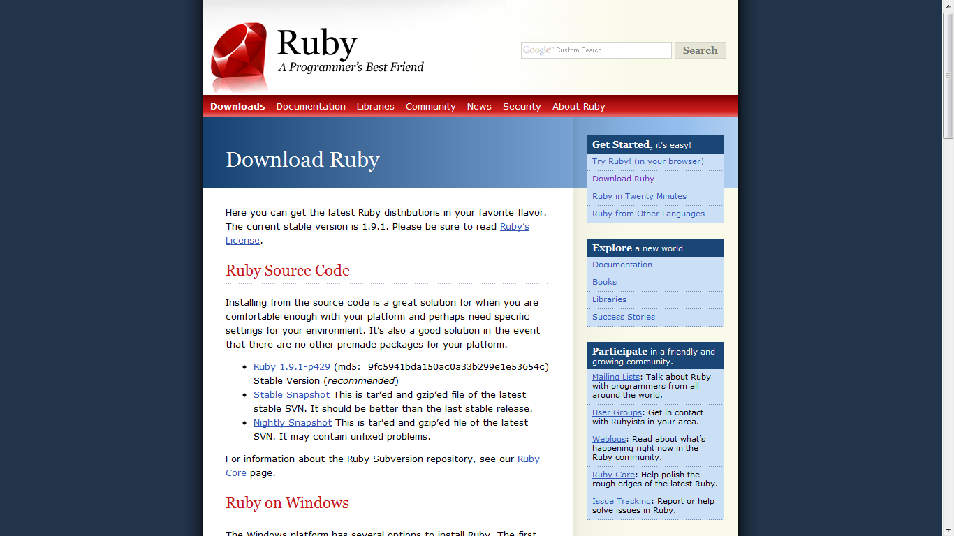
Scroll little down till you see ruby on Windows as shown
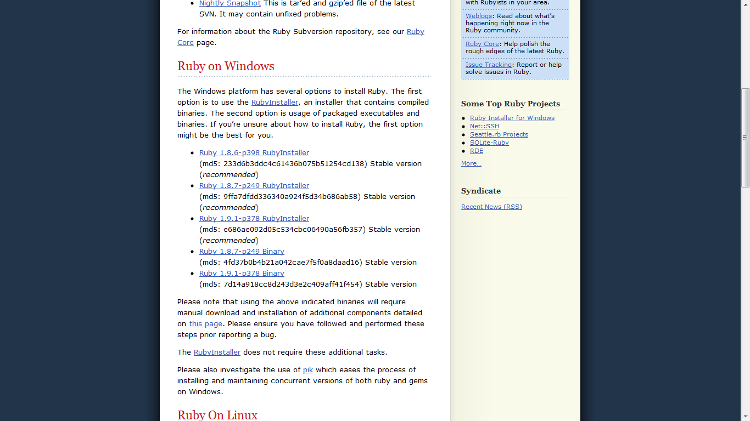
Click on Ruby 1.9.1-p249 link and Ruby installer will get downloaded. You will be asked weather to run it or not. Click on Run
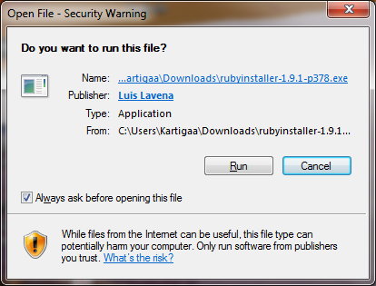
The Ruby installer will start to install Ruby on your system, when you see a window as shown below,click next
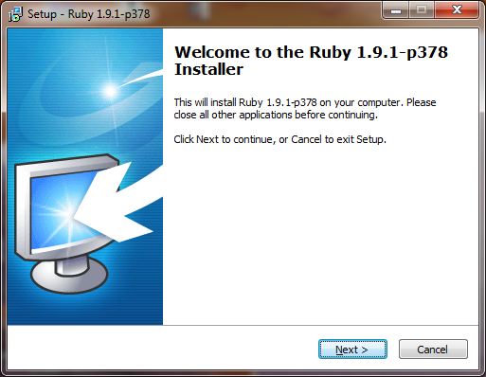
You will be shown a license agreement, don't keep reading all those stuff, select 'I accept blah blah' and click Next
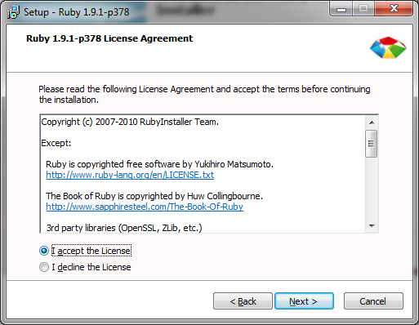
Next, the Ruby installer will ask some options, as shown below, make sure that the two check boxes 'Add Ruby executables to your PATH' and 'Associate .rb and .rbw files with this Ruby installation' are checked. This will ensure seamless working of Ruby on your computer. Click Install.
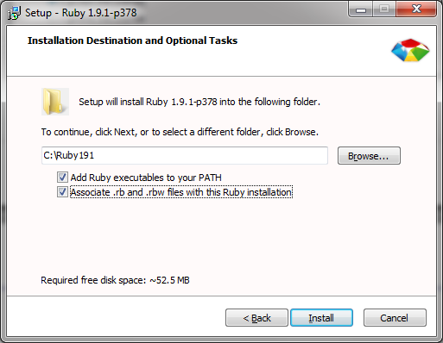
And once done you can see the Ruby installer installing Ruby. If you start to hate Ruby while this is going on, you can press the cancel button to abort it.
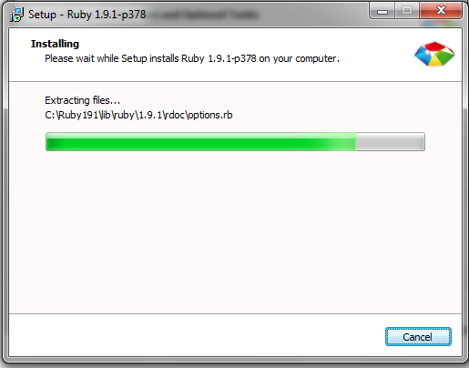
Once the installation is finished, you will see a screen as shown
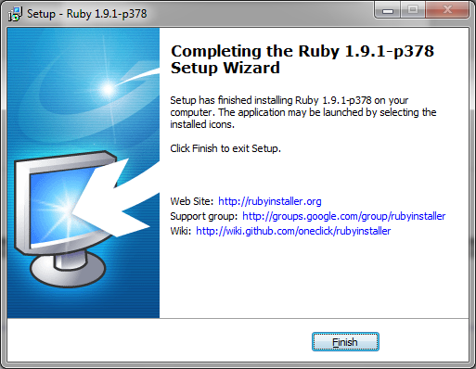
Click Finish, and its done. This installation on Windows is really tough compared with Linux. So try using a free software to run your computer.
Once you have installed, its better to check your Ruby installation. Goto your command prompt, type irb , you can see interactive Ruby prompt, now type puts “Hello World!” , if you get output as Hello World! , then you have struck it right. Bingo!
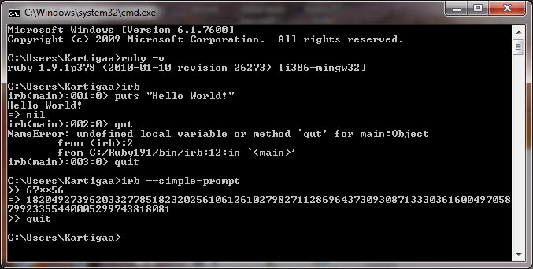

Installing IDE
You need a good IDE (Integrated development environment) to get started with Ruby. I recommend simple and light weight IDE Geany. In Ubuntu machine just type
sudo apt-get install geany
for the IDE to get installed. If the system asks for administrator password, provide it.
To check if the software is installed properly, goto Application → Programming → Geany, the program must launch successfully
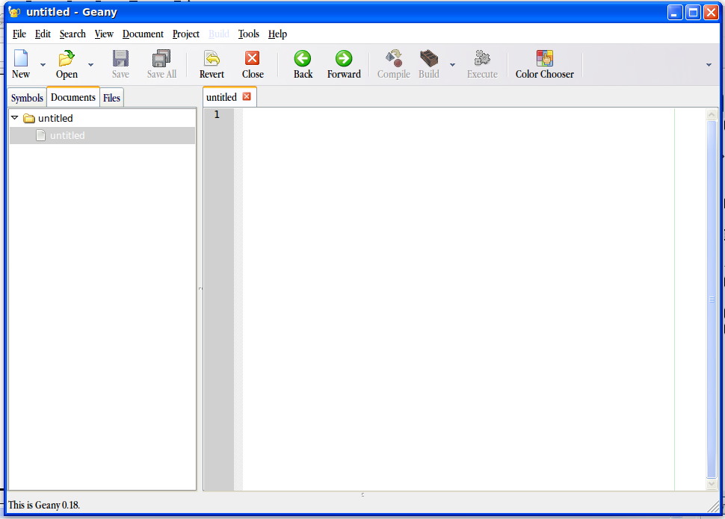

Windows users goto http://www.geany.org/ to download the installer

